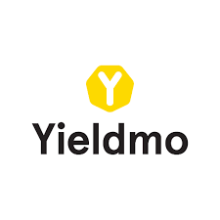

Yieldmo Ads with Google DFP

iOS Integration Guide

v0.1

# 

# 

# Introduction

This document outlines the integration steps needed for DFP customers. By following these instructions, Yieldmo delivers our high-yield formats through DFP. You have to configure Yieldmo in DFP as “Custom Network”.

## Requirements

* Integrate [Google Mobile Ads SDK](https://developers.google.com/mobile-ads-sdk/docs/dfp/ios/quick-start)
* Yieldmo SDK 3.0.2 or above
  + Works with iOS 8 and above
  + Works with Android Jellybean (API 16) and above
* iOS:
  + 2 Adapter files (YMDFPPlacement.h & YMDFPPlacement.m)
* DFP should be configured to allow creative size 300x250 for Window/Pull/Hyperscroller
* Get the following from your account manager
  + App ID - Needed to initialize the SDK
  + Placement ID(s) - Needed for each ad location

## Features

* Delivers 300x250 ads in-content
* Gets location information if passed to DFP

# 

# 

# DFP Setup

Please add every placement/ad unit with Yieldmo as a custom network as shown below:

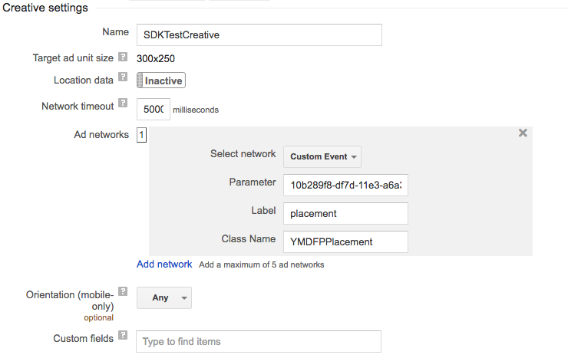

The parameter is your Yieldmo app id followed by the placement id, separated by an underscore. For example: yieldmo-app-id_placementid.

# Integration Steps

1. Integrate our SDK using Cocoapods or .framework integration following instructions from here - <https://github.com/yieldmo/yieldmo-ios-sdk/wiki/iOS-Getting-Started>
2. Drag and drop our custom adapter files (YMDFPPlacement.h & YMDFPPlacement.m)

# 

# Limitations

* Support only few Yieldmo formats: Window, Pull, Hyperscroller
* Yieldmo ads work only if they are embedded as in-content (in a scrollable content) or as a subview of UIScrollView (eg. UITableview, UICollectionView). Otherwise, you won’t get any revenue.
* Currently, we only support **one** Yieldmo placement within a scrollview for DFP
* Clicks are not reported back to DFP. Reporting won’t match for CPC campaigns.

# Questions

Please feel free to reach out our [ads@yieldmo.com](mailto:ads@yieldmo.com) or account manager for any questions.